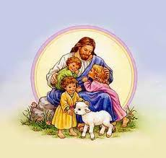
Our Lady of the Magnificat Religious Education
2 Miller Road* Kinnelon, NJ 07405 * 973-838-0567
reled@olmchurch.org or dre@olmchurch.org

Spring, 2026

Dear Religious Education Parents,
It’s that time of year again to register your child for Religious Education 2026-2027 school year.
The tuition information is on the registration form. Tuition is due at the time of registration. Please pay online with a credit card. https://olmchurch.org/httpsolmchurchorgreligious-education-confirmation Please note there is a late fee of $50 for any registration received after June 1, 2026. If finances are an issue, please notify us and we will speak with Fr. Steve on your behalf in order to have your children participate in Religious Education.

Registration will be accepted on a first-come basis. When all grades are full, registration for a particular session will be closed. We will do our best to accommodate each family.

If you are registering a child for the first time, please do not use the "Return Registration Form." New registrations must be completed on the form that is marked "Registration Form (New Student)." For new registrations, be sure to include a copy of your child's Baptismal Certificate. New Student registration forms are available on the OLM Church website (www.olmchurch.org/forms-religious-ed-confirmation) or by emailing the Religious Education Office at reled@olmchurch.org.
We are in need of catechists (teachers) and aides in order for this program to exist. You will learn so much more than you imagine. It is a wonderful way to share your faith with the children of our parish and to grow in your own faith. Please take time to read the enclosed letter (blue) and complete the volunteer form and prayerfully consider joining our team. PERK – tuition is 50% off for your first child if you become a catechist. Note if you will be teaching, please include the full tuition and we will reimburse you the discount.
You can expect to receive the calendar for the program in August.
Together let us continue to improve our program and make it the best for our students! Your suggestions and involvement are always welcome. I am looking forward to continuing this faith journey with you and your family. As I am sure you will agree, the yearly, continuous faith formation of your child is most important to keep that “faith muscle” active and engaged. I ask you to please make Religious Education and attending weekly Mass a priority on your child’s calendar. Their faith will serve them well after all the extra-curricular activities have faded away.
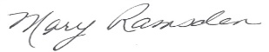
Peace and joy,

Mary Ramsden, DRE

